Second Semester
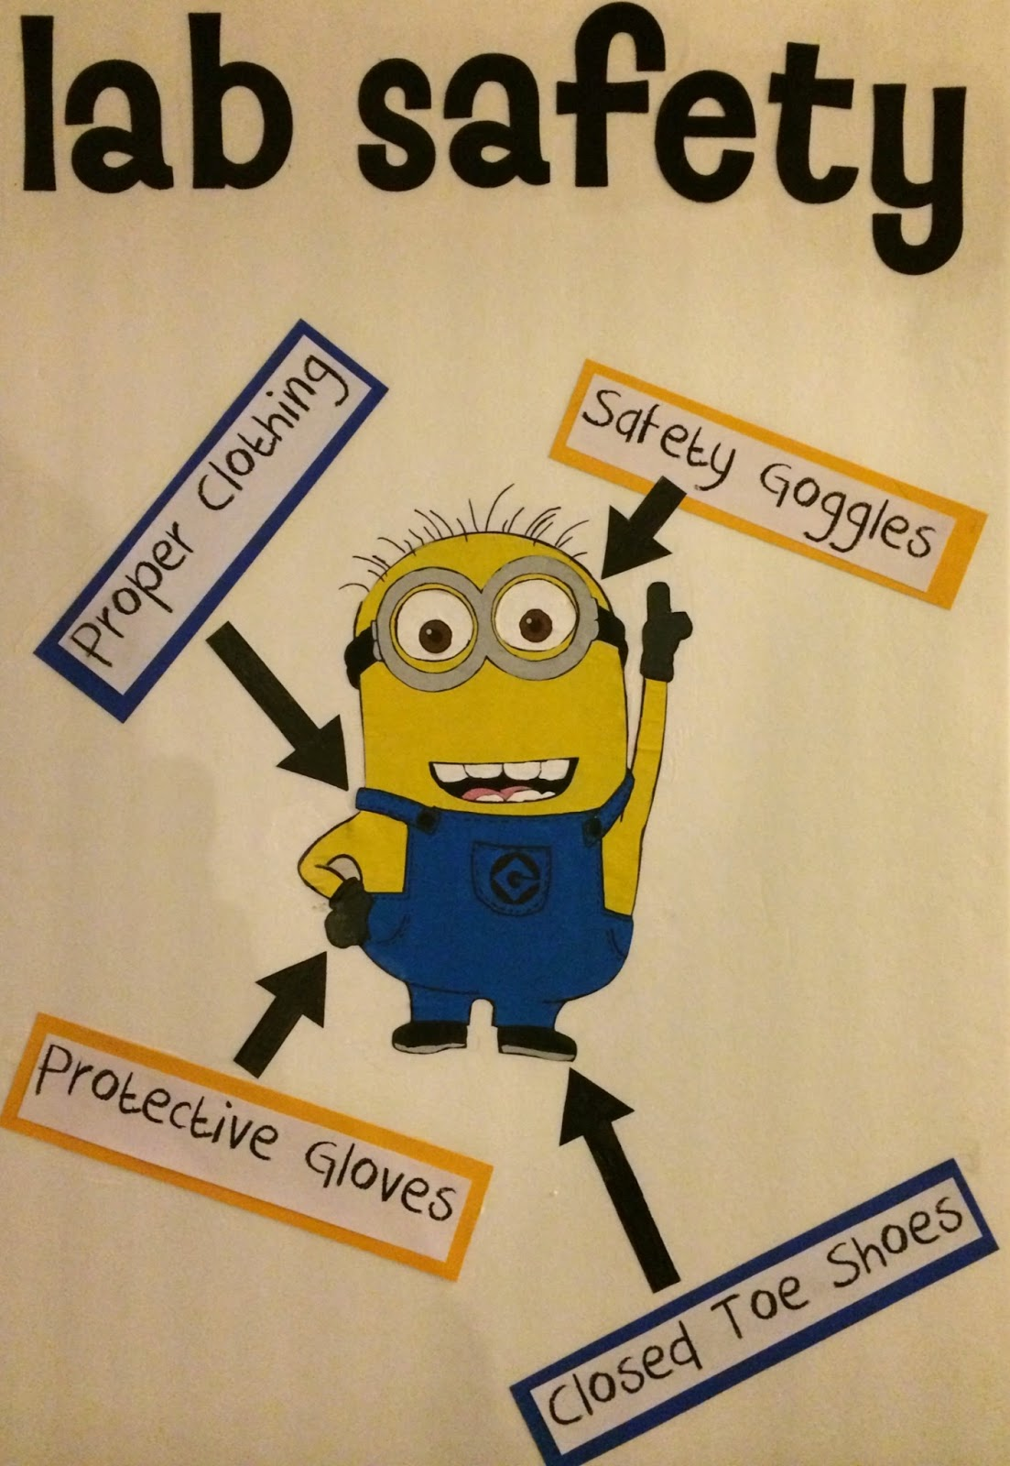
Chemistry B Lab Safety Packet

West Ranch High School
Mrs. Solarez

Contents
District Safety Guidelines (Safety Test- score an 85% or higher)
Laboratory Hazards and Skills (annotate and answer questions)
Laboratory Equipment Worksheet

Appendix P

SAMPLE

PHYSICAL SCIENCE LABORATORY REGULATIONS
WILLIAM S. HART SCHOOL DISTRICT
The following regulations have been compiled for the safety of students performing experimental work in physical science classes. Strict observance of the regulations is mandatory. All students in the school district are to follow these regulations, rather than any conflicting instructions in textbooks or laboratory manuals.

GENERAL

- An instructor must be present during the performance of all laboratory work.
- Prepare for each laboratory activity by reading all instructions before coming to class. Follow all directions implicitly and intelligently. Make a note of any modification in procedure given by the instructor.
- Always approach laboratory experiences in a serious and courteous manner.
- Use only those materials and equipment authorized by the instructor. The teacher must approve any science project or individually planned experiment.
- Know the proper fire and earthquake drill procedures.
- Roll long sleeves above the wrist. Long hanging necklaces, bulky jewelry, and excessive and bulky clothing should not be worn in the laboratory.
- Confine long hair during a laboratory activity.
- Wear shoes that cover the toes, rather than sandals, in the laboratory.
- Wear appropriate eye protection, as directed by the instructor, whenever you are working the in laboratory. Safety goggles must be worn during hazardous activities involving corrosive/caustic chemicals, heating of liquids, and other activities that may injure the eyes.
- Splashes and fumes from hazardous chemicals present a special danger to wearers of contact lenses. Therefore students should preferably wear regular glasses inside splash-proof goggles, when appropriate, during all class activities or purchase personal splash-proof goggles and wear them whenever exposure to chemicals or chemical fumes is possible.
- Place books, purses, and such items in the designated storage area. Take only laboratory manuals and notebooks into the working area.
- Report any accident to the teacher immediately, no matter how minor, including reporting any burn, scratch, cut, or corrosive liquid on skin or clothing.
- Students with open skin wounds on hands must wear gloves or be excused from the laboratory activity.
- Eating or drinking in the lab or from lab equipment is not permitted.
- Students are not permitted in lab storage rooms or teachers’ workroom without the approval of the teacher.

HANDLING EQUIPMENT

- Inform the teacher immediately of any equipment not working properly.
- Report broken glassware, including thermometers, to the instructor immediately.
- Operate electrical equipment only in a dry area and with dry hands.
- When removing an electrical plug from its socket, pull the plug, not the electrical cord.
- When heating material in a test tube, do not look into the mouth of the tube or point it in the direction of any person during the process.
- When working with lasers or apparatus that produce X-Rays, microwaves, or ultraviolet rays, make certain that proper shielding and other precautions are used.
- Know the location of the emergency shower, eye and face wash fountain, fire blanket, fire extinguisher, fire alarm box, and exits.
- Light gas burners only as instructed by the teacher. Be sure volatile materials (such as alcohol or acetone) are far from the burner flame.
- Use a burner with extreme caution Keep your head and clothing away from the flame and turn it off when not in use.
- Use a fire blanket to extinguish any flame on an object in chemistry only. See stop, drop and roll procedure in Chapter 2, section C.
- Use the fume hood whenever noxious, corrosive, or toxic fumes are produced or released.
- To cut small-diameter glass tubing, use a file or tubing cutter to make a deep scratch. Wrap the tubing in a paper towel before breaking the glass away from you with your thumbs. Fire polish all broken ends.
- When bending glass, allow time for the glass to cool before further handling. Hot and cold glass has the same visual appearance. Determine whether an object is hot by bringing the back of your hand close to the object.
- Match hole size and tubing when inserting glass tubing into a stopper. If necessary, expand the hole first by using an appropriate size cork borer. Lubricate the stopper hold and glass tubing with water or glycerin to ease insertion, using towels to protect the hand. Carefully twist (never push) glass tubing into stopper holes.

HANDLING CHEMICALS

- Check labels and equipment instructions carefully. Be sure correct items are used in the proper manner.
- Be aware if the chemicals being used are hazardous. Know where the material safety sheet (MSDS) is and what it indicates for each of the hazardous chemicals you are using.
- Never pour reagents back into bottles, exchange stoppers of bottles, or lay stoppers on the table.
- When diluting acids, always pour acids into water, never the reverse. Combine the liquids slowly while stirring to distribute heat buildup throughout the mixture.
- Keep hands away from face, eyes, and clothes while using solutions, specimens, equipment, or materials in the Laboratory.
- To treat a burn from an acid or alkali, wash the affected area immediately with plenty of running water. If the eye is involved, irrigate it at the eyewash station without interruption for 15 minutes. Report the incident to your instructor immediately.
- Never carry hot equipment or dangerous chemicals through a group of students.
- Use a mechanical pipette filler (never the mouth) when measuring or transferring small quantities of liquid with a pipette.
- Never taste anything or touch chemicals with the hands unless specifically instructed to do so.

- Test for odor of chemicals only by waving your hand above the container and sniffing cautiously from a distance.

CLEANUP AND DISPOSAL

- Be sure all glassware is clean before use. Clean glassware thoroughly after use. Residue may cause errors in new experiments or cause a violent reaction or explosion.
- Keep work areas clean. Floors and aisles should be kept clear of equipment and materials.
- Clean up any spill on the floor or workspace immediately.
- Dispose of laboratory waste as instructed by the teacher. Use separate, designated containers (not the wastebasket) for the following:
- Matches, litmus paper, wooden splints, toothpicks, and so on.
- Broken and waste glass
- Rags, paper towels, or other absorbent materials used in the cleanup of flammable solids or liquids
- Hazardous/toxic liquids and solids
- Remove all broken glass from the work area or floor as soon as possible. Never handle broken glass with bare hands; use a counter brush and dustpan.
- Always clean the laboratory area before leaving.
- Students and teacher wash hands with soap and water before leaving the laboratory area.

Note: Persistent or willful violation of these regulations or classroom rules and procedures during laboratory sessions will result in the loss of laboratory privileges and possible dismissal from the class. Please see the “Student Safety Contract—Chemistry” in your syllabus.
Laboratory Hazards and Skills in the Chemistry Classroom

Directions: Read each section, annotate by circling 10 words (one word not a phrase) for each section and then answer the questions for each section.

Introduction: Chemistry is exciting! Each day in the laboratory you are given the opportunity to confront the unknown, and to understand it. Each experiment holds many secrets. Look hard and you may see them. Work hard and you will solve them. The word science comes from the Latin word scire, which means “to know”. The goal of all science is knowledge.
Chemistry is a laboratory science. To get the most of your laboratory experience, you must be well prepared for each experiment. This means that you must read the experiment thoroughly before coming to the laboratory. Make sure that you understand each step of the procedure. If you are unsure of any part of the experiment, ask your teacher for help before the laboratory begins.

Safety: As part of your laboratory experience you will handle many chemical substances and manipulate specialized laboratory equipment. Some of the laboratory equipment and chemical substances can cause severe injury or illness if used improperly. If you are well prepared for the laboratory, it is much less likely that an accident will occur. Before you begin a laboratory experiment, note the safety warnings and the general safety precautions described in the safety section of each lab. The most important safety rule to follow at all times is to: Always wear safety goggles in the laboratory area!

Laboratory Hazards –Section 1
- This safety section is intended to acquaint you with the hazards that exist in the laboratory and to indicate how you can avoid these hazards.

1. Thermal Burns: A thermal burn can occur if you touch hot equipment or come too close to an open flame. You can prevent thermal burns by being aware that hot and cold equipment look the same. If a gas burner or hot plate has been used, hold your hand near it to feel for heat before touching it. Treat a thermal burn by immediately running cold water over the burned surface for a few minutes until the pain is reduced. Greases or oils should never be used to treat burns because they tend to trap heat in burned tissue. Notify your teacher immediately if you are burned.

2. Chemical Burns: A chemical burn occurs when the skin or a mucous membrane is damaged by contact with a substance, like a strong acid or strong base. The safety section of each lab indicates which substances can cause chemical burns. “C” stands for corrosive, which indicates that the substance can cause severe burns like sulfuric acid and hydrogen peroxide. “I” stands for irritant, which indicates that the substance can irritate the skin or the membranes of the eye, nose, throat, or lungs. Chemical burns can be severe and mucous membranes can be damaged permanently.
For example: The estimated time for permanent corneal damage from 1-M NaOH is only 30 seconds. The best defense against chemical burns is preventing them. Wear safety goggles during all phases of the laboratory experiment even during clean-up.
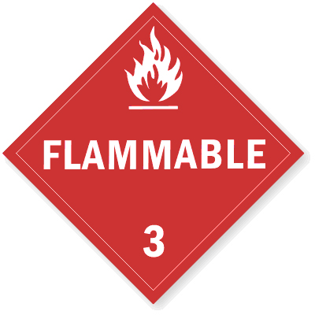
3. Fire: A fire may occur if chemicals are mixed improperly or if flammable materials come too close to a burner flame or hot plate. Flammable chemicals are designated with the symbol “F”. During laboratory experiments, all long hair needs to be tied back and loose-fitting clothing is not allowed.

4. Poisoning: Many of the chemicals used in the laboratory are toxic and are identified with the symbol “P”. In the laboratory, never eat, chew gum, or drink anything. Always wash your hands before leaving the laboratory area.

Questions:
1. What type of burn occurs when the skin or mucous membrane is damaged? _____________________________
2. To treat a ________________ burn you need to immediate run ____________water over the burned surface.
3. The letter “I” stands for ______________________.
4. A substance can irritate what parts of the membrane? _________________________________________
5. The letter “C” stands for ______________________.
6. Give an example of a corrosive chemical. _________________________
7. During lab, what is the proper way to wear your hair? _________________________________________________
8. What type of chemical is a known irritant? _______________________________________
9. What is the most important piece of lab safety equipment? ________________________________

Laboratory Skills – Section 2
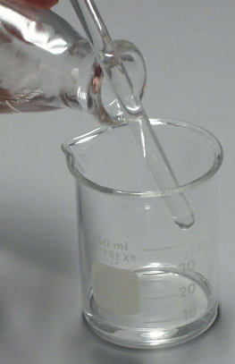
Directions: Read each section, annotate by circling 10 words (one word not a phrase) for each section and then answer the questions for each section.

- When working in the chemistry laboratory, you will be handling potentially dangerous
substances and performing unfamiliar tasks. This section provides you with a guide to the
various laboratory techniques, which will be used during the course.

1. Pouring Liquids: Always read the label on a reagent bottle before using its contents.
Never pour excess liquid back into the original reagent container. Excess liquid should be disposed
of in the proper waste container. When you are transferring a liquid to a test tube or measuring
cylinder, the container should be held eye level. Pour the liquid slowly, until the correct volume
has been transferred. When pouring a liquid from a reagent bottle into a beaker, the reagent should be
poured slowly down a glass stirring rod. See picture.

2. Measuring Mass with an electronic balance: An object’s mass is determined by measuring it on a triple-beam balance or an electronic balance. The SI unit for mass is the gram.

To operate an electronic balance, follow the general rules:
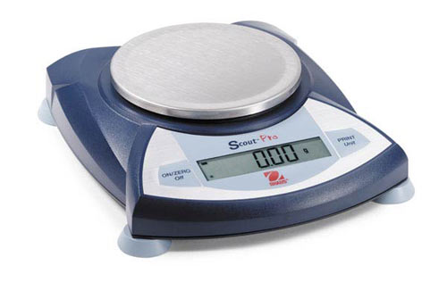
- Never place a chemical directly on the balance pan, a weighing boat must be used. Place a weighing boat on the balance only when granular substances are used.
- All other substances can be weighed without a weighing boat.
- Zero out (0.00 g) the balance before any objects are weighed by touching the key
pad labeled “zero”.
- Place the object to be weighed on the balance and wait for a reading.
- Record one number past the decimal.
- NO liquids can be measured on the balance.

3. Filtering a Mixture: The most common method of separating a heterogeneous mixture is filtration.
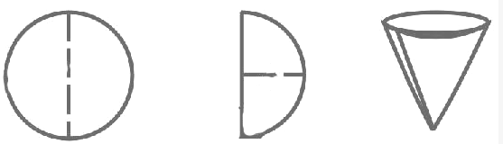
- Fold a filter paper in half and then into quarters. Open the folded paper to form a cone, with one thickness of paper on one side and three thickness of paper on the other side.
- Put the paper cone in a filter funnel. Moisten the filter paper with a small volume of distilled water, and gently press paper against the sides of the funnel to achieve a good fit.
- Place the filter funnel inside a beaker and slowly decant the liquid through the funnel into the beaker.
- When the filtration is complete, wash the solid residue on the filter paper with distilled water to remove traces of solvent. Dry the solid.

4. Measuring Volume and reading the meniscus: Most volume measures in the laboratory are made using equipment
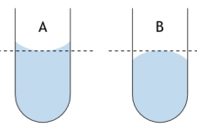
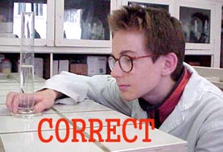
calibrated in millimeters. Beakers have graduation marks, but these marks are designed
only for quick, rough estimates of volume. Accurate volumes must be measured using
volumetric or graduated pipettes, burets, or volumetric flasks. A volume measurement
using a graduated cylinder is always read with the meniscus at eyelevel and by reading
the bottom of the meniscus. See the picture. To make the meniscus more visible, you
may place your finger or a dark piece of paper behind and just below the meniscus while
making the reading.
Questions:
1. What piece of equipment is used on top of a balance to weigh chemicals? ___________________
2. A graduated cylinder is measured in what unit? _________________________ When reading the ________________ you need to be at _____________ with the graduated cylinder
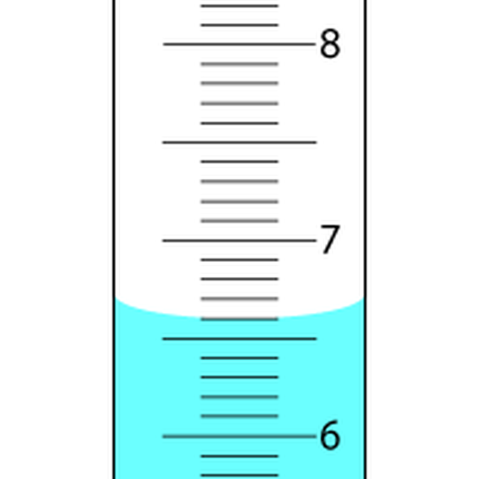
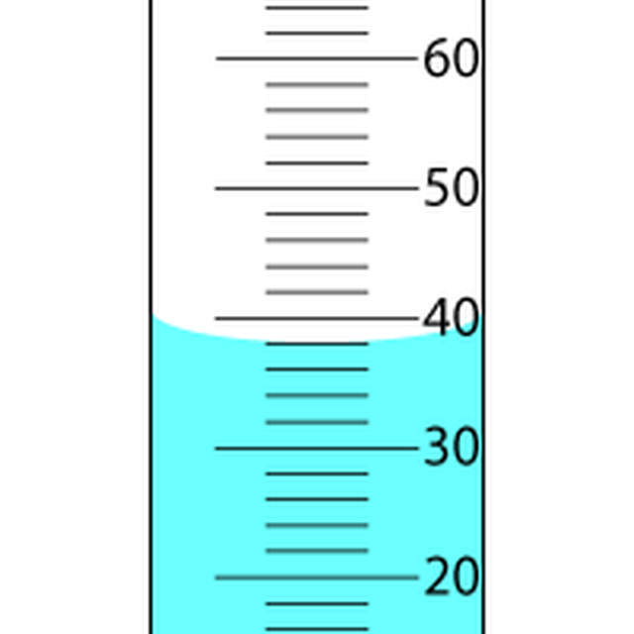
3. Read the following graduated cylinders.
Volume __________
Volume __________
Laboratory Skills – Section 3
Directions: Read the section, annotate by circling 10 words (one word not a phrase) for each section and then answer the questions for each section.

1. Using a Burner:
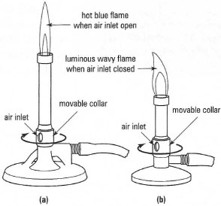
The two most common types of burners are the Bunsen and the Tirrell Burner. Many chemistry experiments require something to be heated. Before attempting to light any lab burner, check to see that the jet hole between the base and the burner tube is free of obstruction. If chemicals have covered this jet, the burner will not operate properly.
After attaching the hose to the gas outlet, turn the handle on the outlet
parallel to the nozzle to open the gas valve. The gas valve is turned off by
turning the handle 90 degrees in either direction. Carefully check to see that
you hear gas escaping from the mouth of the burner tube. When you are sure
that you have gas, bring the head of the striker over the burner and squeeze the
striker handle. The spark produced will ignite the gas and your burner is lit.
Adjust the air control vent so that the flame has the proper blue color. A yellow
flame is an indication of a lack of oxygen, meaning that the air vent needs to be
opened. The hottest part of the burner flame is just at the top of the bright blue
inner cone. Normal heating is done with an object at the top of the light blue outer
cone, while strong heating is done with an object at the top of the bright blue
inner cone. To heat a container gently, move the container back and forth through the outer cone.
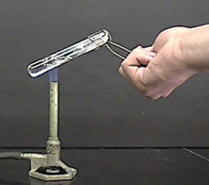
2. Heating Liquids:
To heat a liquid in a test tube, first grasp the test tube with test tube tongs and then hold
the test tube in a slanting position in the flame and gently heat the test tube a short distance
below the surface of the liquid. Never point the open end of the test tube that you are
heating toward yourself or in the direction of others working nearby. Shake or swirl the
test tube gently as it heats, until the liquid is boiling or has reached the desired
temperature.

3. Titrations:
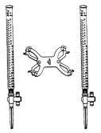
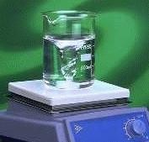
The classic lab apparatus for a titration uses a set of double burets - pictured here. One buret holds the acid, the other the base. The common procedure is to place a measured volume of the acid into a flask, then add two drops of phenolphthalein indicator. This indicator is colorless in an acid, but turns dark pink in a base. Small amounts of the base are added to the flask as it is being slowly twirled to mix the solution. At the end-point, or "neutralization", the phenolphthalein will be barely pink when viewed over a white background.
4. Magnetic Stirrer:
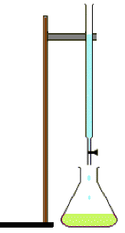
A magnetic stirrer is helpful for dissolving solids in liquids. While there are several different styles, all will at least have a base with a speed-controlled spinning magnet inside and an external stirring bar. The stirring bar is placed into a flask or beaker by gently sliding it along the wall of the container. To prevent breakage, do not drop the bar onto the bottom of the container. Place the container on the stirrer base and turn the speed control knob to its lowest setting. Use just enough speed to start the bar turning in the container. The picture here shows the "vortex" that forms inside the container. Be patient, the bar might "hop" at excess speeds, causing splashing. If using exact volumes, as with a volumetric flask, be sure take the measurements before adding the stirring bar. When stirring is completed, keep the stirring bar in the container by "decanting" the liquid into another container. Be sure to carefully wash the original container and the stirring bar.
Questions:
1. Label the ring stand, buret and Erlenmeyer flask in the picture to the right.
2. What is the hottest part of the flame?___________________________
3. When you heat a test tube in a flame, what piece of equipment is used to hold the test tube? ____________________
4. How do you hold the test tube in the flame? _____________________________________
5. Label the hottest part of the flame in the burner below.
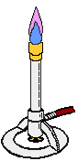
Experimental Design- Section 4
Directions: Read the section, annotate by circling 10 words (one word not a phrase) for each section and then answer the question for each section.

1. What's a variable?
A variable is an object, event, idea, feeling, time period, or any other type of category you are trying to measure. There are two types of variables-independent and dependent.

2. What's an independent variable? “The cause”
An independent variable is the variable you have control over, what you can choose and manipulate. It is usually what you think will affect the dependent variable. In some cases, you may not be able to manipulate the independent variable. It may be something that is already there and is fixed, something you would like to evaluate with respect to how it affects something else, the dependent variable like color, kind, or time .
- The one thing that is changed in an experiment
- This variable makes one test “independent” of another test
- On a graph it is on the x-axis(along the bottom)

3. What's a dependent variable? “The effect”
A dependent variable is what you measure in the experiment and what is affected during the experiment. The dependent variable responds to the independent variable. It is called dependent because it "depends" on the independent variable. In a scientific experiment, you cannot have a dependent variable without an independent variable. The result of the experiment
- What is measured
- This “depends” on what you changed
- On a graph, it is on the y-axis(along the vertical side)
Many people have trouble remembering which the independent variable is and which the dependent variable is. An easy way to remember is to insert the names of the two variables you are using in this sentence in the way that makes the most sense. Then you can figure out which is the independent variable and which is the dependent variable:
(Independent variable) causes a change in (Dependent Variable) and it isn't possible that (Dependent Variable) could cause a change in (Independent Variable).
The independent variable causes the dependent variable to change

Examples:
- A scientist studies the impact of a drug on cancer. The independent variables are the administration of the drug - the dosage and the timing. The dependent variable is the impact the drug has on cancer.
- A scientist studies the impact of withholding affection on rats. The independent variable is the amount of affection. The dependent variable is the reaction of the rats.
- A scientist studies how many days’ people can eat soup until they get sick. The independent variable is the number of days of consuming soup. The dependent variable is the onset of illness.

How do you identify independent and dependent variables?
- Figure out your variables.
- What 2 things are you measuring? Volume? Time? Mass? Behaviour?
- Whatever they are, you will control one and the other one is out of your control. The variable you control is the independent variable, the one you don't (the outcome) is the dependent variable.

5. What is the control?
The control is the standard against which the researcher compares the results from each treatment group (level) in the experiment. For example, the control might be the room temperature water, which is about 20° C. In many cases, there will not be a true control. The researcher could then set one of the groups as the standard and measure the other groups against that standard.

6. What is a constant?
A constant is a variable that does not change during the experiment so that it can be sued as a base for comparison.

Question:
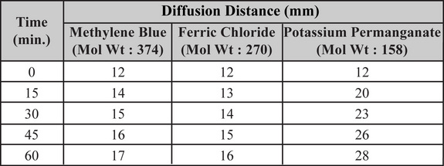
A student conducted an investigation to study the rate of diffusion of some chemicals. The observations were recorded in the table given below:

Which of the following is an independent variable in this investigation?
a. quantity of chemicals used
b. diffusion distance
c. velocity of the diffused particles
d. duration of the experiment

General Chemistry

Lab Equipment Names and Functions
Directions: Below you will find the names of different kinds of lab equipment you may encounter this semester. Additionally, the function associated with these various types of equipment are listed in the next table. Complete the attached chart on the lab equipment worksheet by writing in the correct name and the function of the equipment with the appropriate visual from the lists given. You will be taking an equipment quiz.

Lab Equipment Names

Buret | Thermometer
Forceps | Pipetter
Graduated cylinder | Crucible and Cover
Pipe stem triangle | Scoopula
Goggles | Test Tube rack
Erlenmeyer flask | Beaker
Test tube tongs | Balance
Beaker tongs | Crucible tongs
Funnel | Graduated pipet
Ring stand | Test Tubes
Buret clamp | Tirrell burner
Hot plate/stirrer | Wash Bottle

Lab Equipment Functions

used to hold hot beakers | used to measure approximate volumes in ml
used to measure mass | holds crucible in a flame
holds burets in place when titrating | source of heat/flame using gas
used in titrations to hold volume | used to measure volumes of solution during titrations
used to pick up small dry objects | use to measure liquid with a pipetter
mechanically mixes solutions while heating | used to accurately draw up liquid into pipet
used to heat small amounts of substances at high temperature | LEAST accurate in measuring volume
used to pick up a crucible | used as a support for lab equipment
eye protection | used to transfer solid chemicals
a clamp that holds a test tube | used with filter paper
holds test tubes | mix small quantities of liquids and solids
measures temperature | contains distilled water, used for rinsing

General Chemistry Name: ________________________________________ Date: ____________

Visual | Name of Equipment | Function


