AP Environmental Science Name ____________________________________
Nature: Survivors of the Firestorm
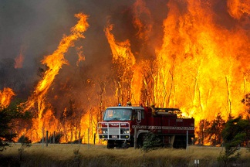
http://video.pbs.org/video/1886751593/
- Describe the unique ecosystem of the forest in Australia:

- What does it mean when a forest is deteriorating?

- Why is summer in February in Australia?

- How many fires occurred on Black Saturday? _________________ How many degrees were some of the fires at the core? _______________________.

- Koalas are picky eaters. Explain:

- Are koalas generalist or specialists? ________________________________________

- How do fires help seeds?

- What are cockatoos eating and why?

- What two plants are the first colonizers after the fire?

- What predators move into the burned forest?

- Are these predators successful? Explain:

- Describe the situation regarding the endangered Leadbeater possum:

- How are scientists helping the possum?

- Describe what has occurred with stream quality:

- How has the stream quality affected the Galaxias fish?

- Describe a plant that has been helped by fire:

- How long with the Peregrine Falcon stay? ________________________ Why?

- Describe how logging hurts wildlife recovery:

- How many years does it take to reach a fully complex forest? ______________

