6 Week Study Plan for the AP Environmental Science Exam AND the Final Exam
Use this calendar to help you systematically prep for the exam. If you are a quick studier, use the lower suggested time. If you take more time studying, use the higher suggested time.
You can also study other items such as review books and apps. I suggest that you cross off or highlight items on the chart as you do them.
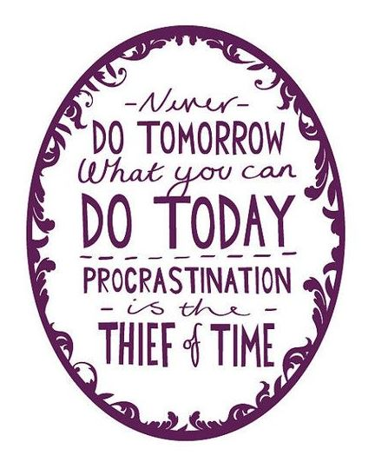
Date of Midterm: _______________________________
Date/s of Final Exam ______________________________
Date of AP Exam ______________________________
Study Dos
- Put your phone in another room
- Don’t watch TV or be on the computer
- Eat a snack (brain power!)
- Listen to classical or soothing music or no music at all
- Find a quiet area
 | Week 1 (Mar 20) | Week 2 (Mar 27) | Week 3 (Apr 3 Spring Break) | Week 4 (Apr 10) | Week 5 (Apr 17) | Week 6 (Apr 24)
Time per day | 15-30 min | 15-30 min | 30-60 min | 30-60 min | 1-2 hours | 1-2 hours
Memorize Sticky Notes | Chapter 1, 2, 3 | Chapters 4, 5, 6, 7, 8 | Chapters 9, 10, 11, 12, 13 | Chapters 14, 15, 16, 17 | Chapters 18, 19, 20, 21, 22 | Go back over sticky notes
Review items/handouts in binder | Chapter 1, 2, 3 | Chapters 4, 5, 6, 7, 8 | Chapters 9, 10, 11, 12, 13 | Chapters 14, 15, 16, 17 | Chapters 18, 19, 20, 21, 22 | All items
Pearson Education Test Prep Series Book | Introduction (pgs. 1-16), Topics 1 & 2 | Topics 3 & 4 | Topic 5 | Topics 6 & 7 | Topics 8 & 9 | Practice Test
Bozeman Science Videos | 001, 002, 003, 007, 008, 010 | 009, 011,012, 013, 014, 015, 021 | 006, 009, 035, 016, 017, 018 | 005, 020, 029, 030, 032, 033, 034, | 004, 019, 022, 023, 024, 025, 026, 027, 028, 031
Review papers |  |  | APES Review worksheet | Vocabulary review  Geography review | Math/chemistry review | All Review Sheets
http://www.bozemanscience.com/ap-environmental-science

